**Verify Environment Access**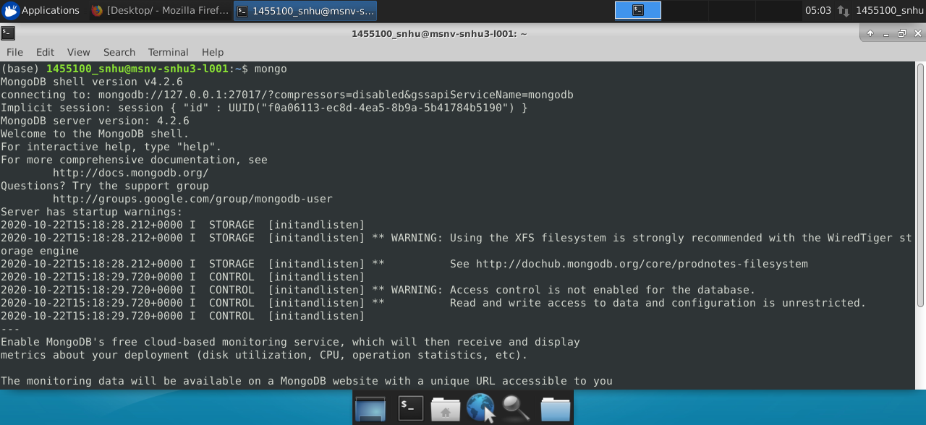

**Mongo Shell Commands: Retrieve Document**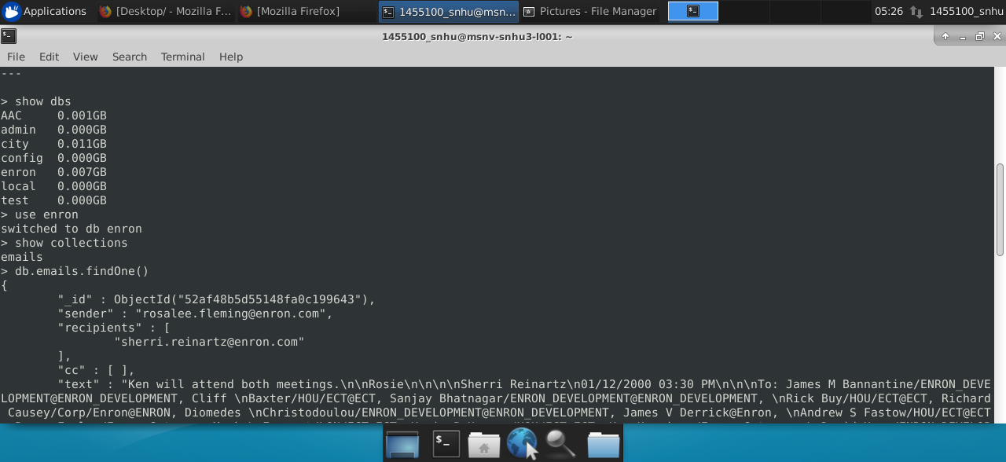

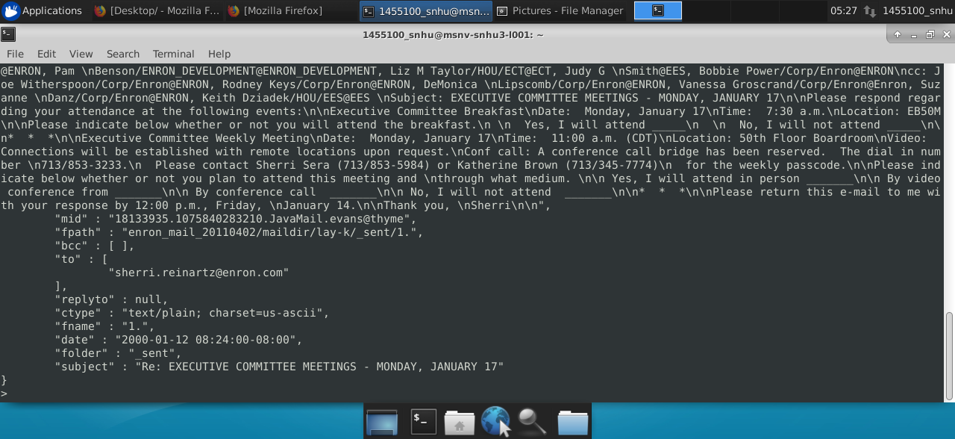

**Mongo Shell Commands: Find Size of Single Document**

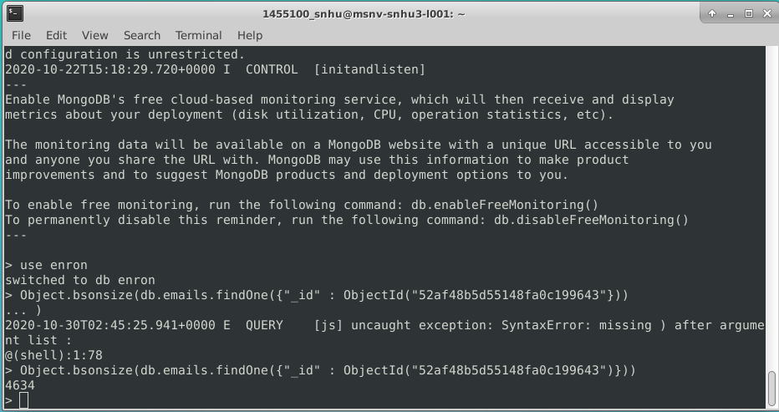

**Mongo Shell Commands: Find Size of Collection of Documents**

Size of *emails* collection (“**size**”):

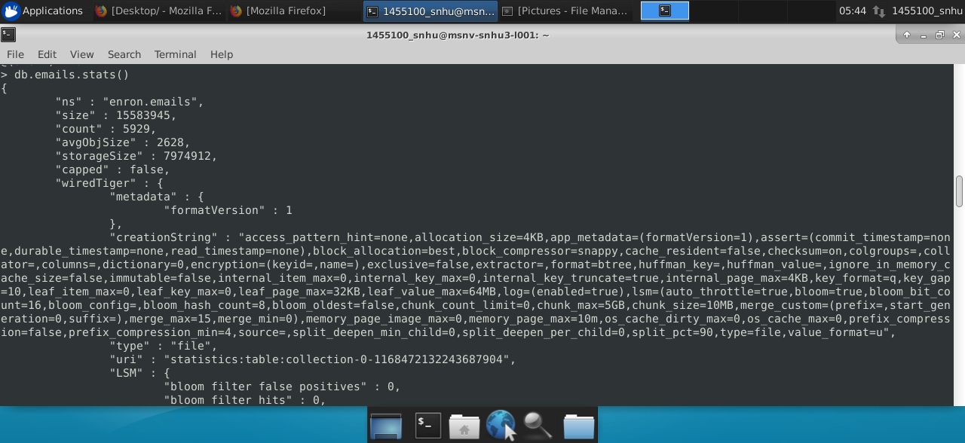

Size of *enron* database (“**dataSize**”):

